Arduino transceiver

3.3V source

Yellow – Output

Red is high Vin, black is GND

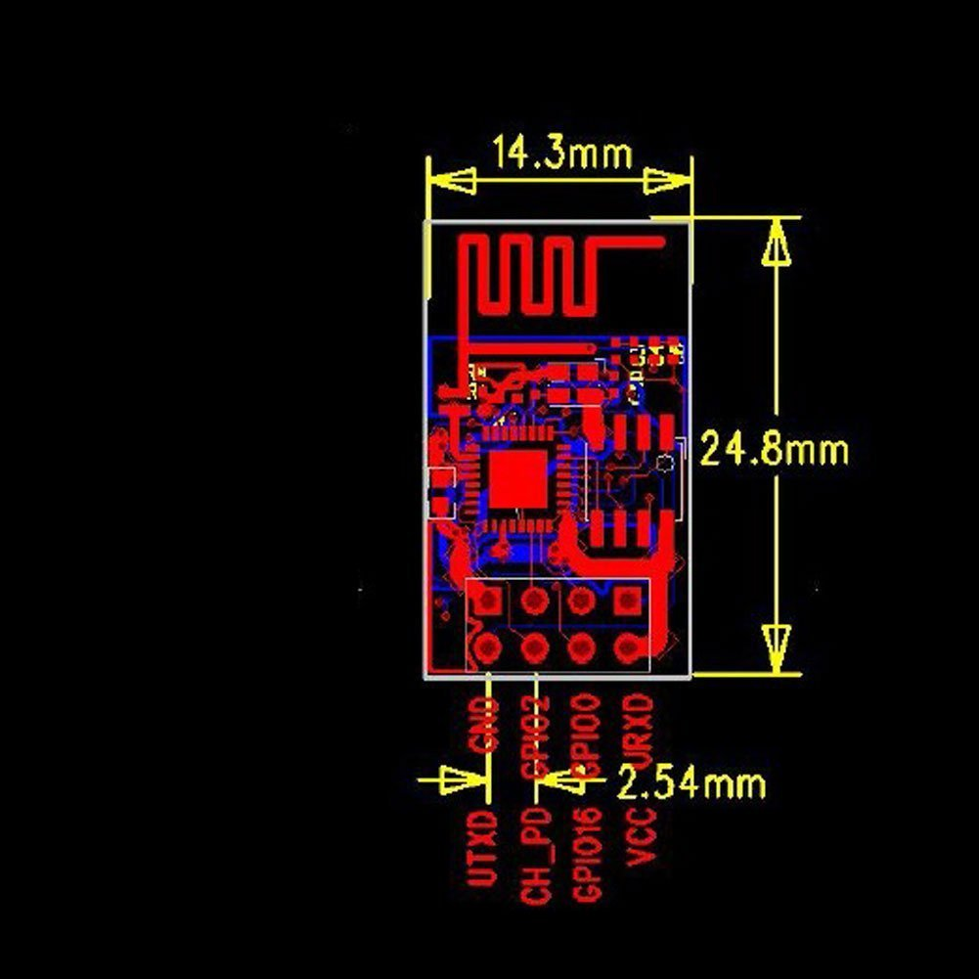

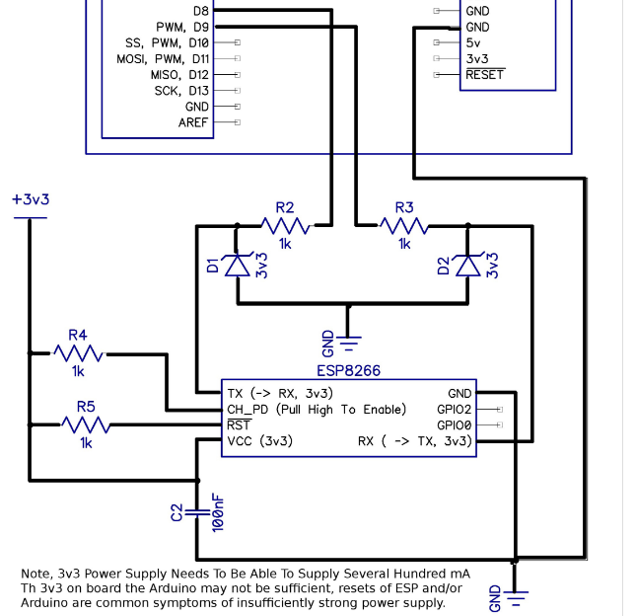

??? 

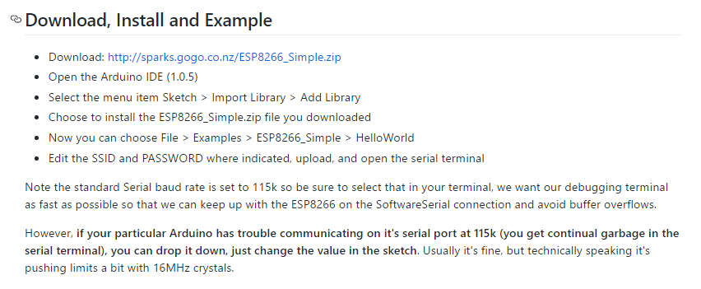

Also see:

<http://allaboutee.com/2014/12/27/esp8266-arduino-code-and-circuit/>